# **Debugging Azure Function Locally**

Link: <https://stackoverflow.com/questions/21114066/attach-intellij-idea-debugger-to-a-running-java-process>

**Image:**

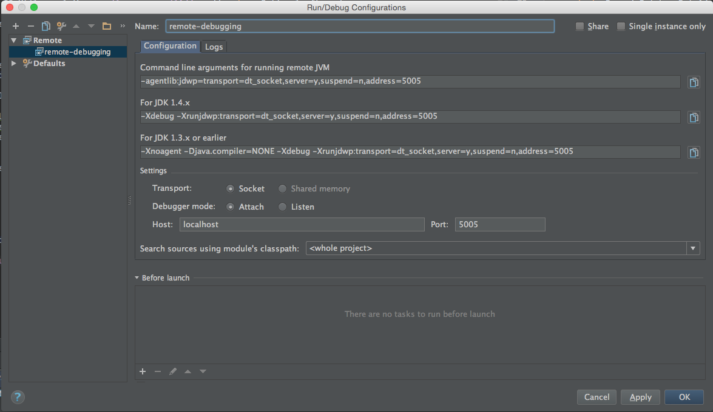

# **Command to Run Azure Functions**

1. mvn install package azure-functions:deploy
2. mvn package azure-functions:run
3. mvn package azure-functions:run -DenableDebug
4. mvn package azure-functions:run -DenableDebug

# **Step Adopted for my own case**

1. Set the Remote Debugging from Configuration option

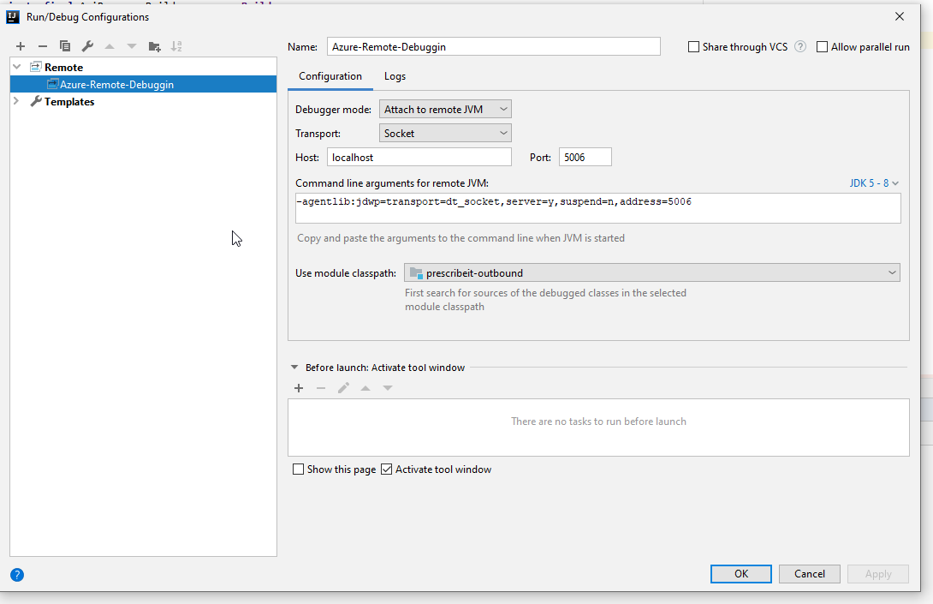

# **Tips**

1. Unit tests to debug functions is better, faster when writing new code rather than using a remote debug.

# Commands

1. **List all the process using**

netstat -a -o

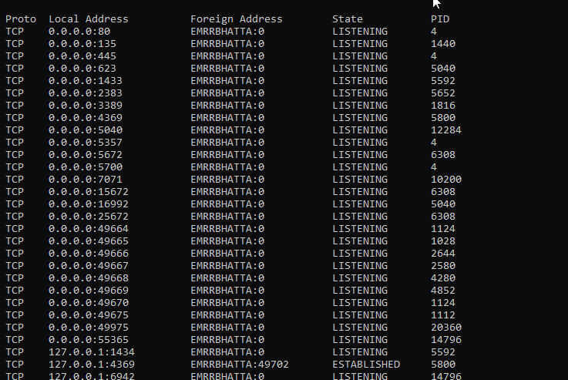

1. **Kill the process using**

Taskkill /PID 26356 /F

# **HOW TO RUN DEBUGGER LOCALLY**

1. Set Maven Debugging command

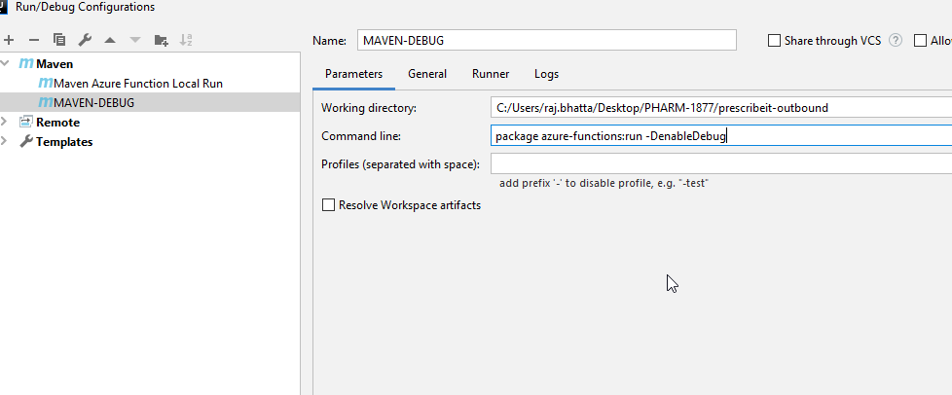

1. Run maven debugging command with button show below set in step 1.

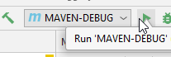

1. Create a remote server debug

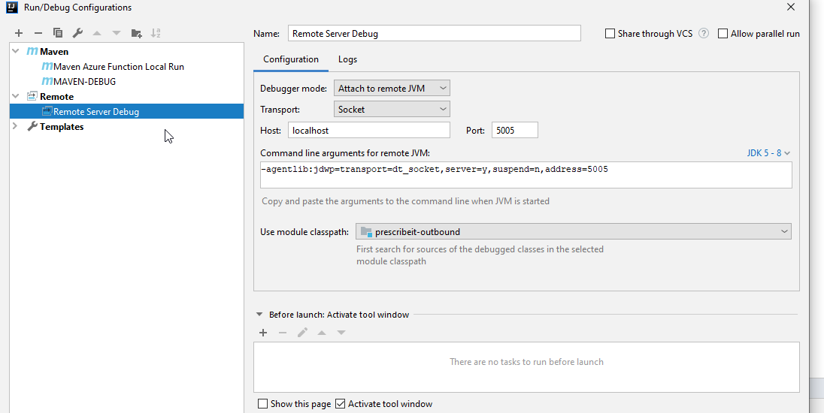

1. Now, select remote server debug and click on debug icon.

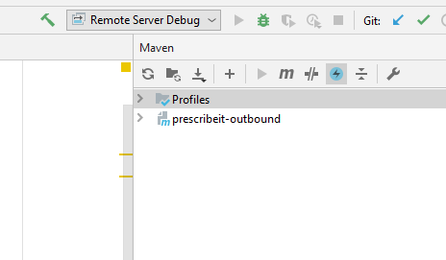

1. Select an event that will fire invocation to breakpoint such as request, trigger or anything.